**A03: NEURAL NETWORK ZOO**

**Team Name:**

Fast Jet Learning Rockets (FJLR)



**Team Members:**

Faiza Abdullah

Jonah Joseph

Lyazzat Zilgarina

Ryan Yauch

**Professor:**

[Patricia Mcmanus](https://eagleonline.hccs.edu/courses/282423/users/264039)

**INTRODUCTION TO NEURAL NETWORKS**

**Neural networks are a cornerstone of artificial intelligence, inspired by the workings of the human brain. These computational models, inspired by the human brain's biological neural networks, process data through interconnected nodes, called neurons, arranged in layers. By adjusting the connections (weights) between neurons, neural networks learn patterns and make predictions. Deep learning, a subset of machine learning, leverages multi-layered neural networks to perform complex tasks such as image recognition, language translation, and time-series forecasting.**

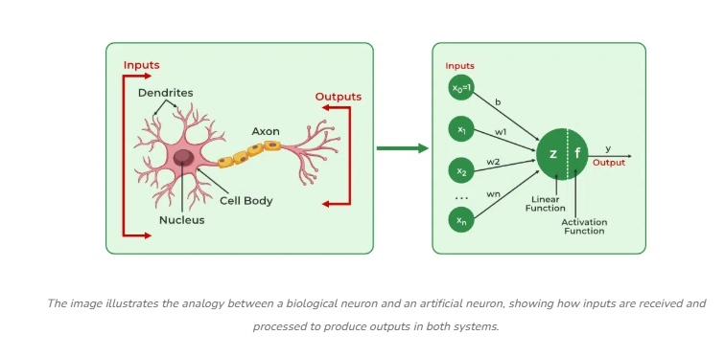

### ****BASIC STRUCTURE OF A NEURAL NETWORK****

### **Neurons are the fundamental units that process and transmit data. The ***Input Layer*** receives raw data, the ***Hidden Layers*** process raw data/information through complex transformations (perform calculations and extract features), and the ***Output Layer*** provides the final prediction or classification. The connections are links between Neurons controlled by ***Weights & Activation functions*** that adjust and refine the learning process.**

### nn-ar-Geeksforgeeks

### ****TYPES OF NEURAL NETWORKS****

### 3.1 Feedforward Neural Network (FNN) - The Ant Colony

* **Characteristics**:
  + Unidirectional information flow
  + Basic building block of neural networks
  + Layer-by-layer processing
* **Animal Parallel**: Like ants marching in formation, data moves forward in an organized manner
* **Applications**:
  + Basic pattern recognition
  + Classification tasks
  + Simple prediction models
* **Strengths:** Easy to implement and computationally efficient.
* **Limitations: Cannot handle sequential data effectively.**

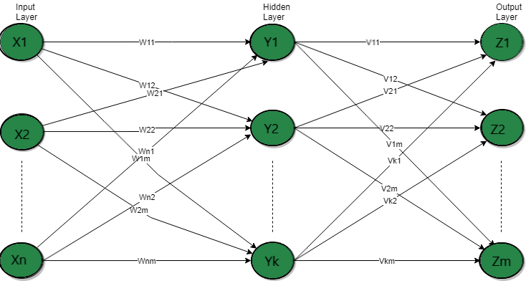

### 3.2 Convolutional Neural Network (CNN) - The Eagle

* **Characteristics**:
  + Specialized for spatial data
  + Uses convolution operations
  + Feature detection hierarchy
* **Animal Parallel**: Eagles have exceptional visual acuity and pattern recognition
* **Applications**:
  + Image processing
  + Computer vision
  + Video analysis
  + Facial recognition
  + Medical imaging
  + Object detection
* **Strengths: Excellent for spatial data and hierarchical feature extraction.**
* **Limitations: Requires large datasets and high computational power.**

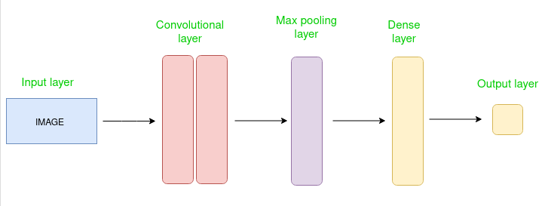

### 3.3 Recurrent Neural Network (RNN) - The Parrot

* **Characteristics**:
  + Processes sequential data
  + Internal memory state
  + Feedback loops
* **Animal Parallel**: Parrots learn and repeat sequences while maintaining context
* **Applications**:
  + Natural language processing
  + Time series prediction
  + Speech recognition
  + Sentiment analysis
* **Strengths: Maintains contextual information over sequences.**
* 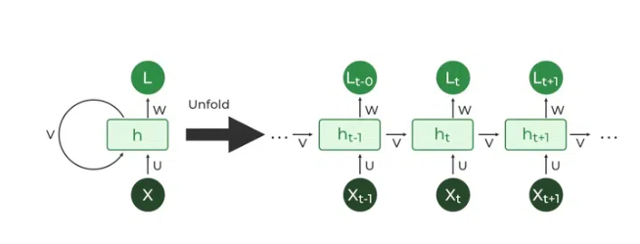**Limitations: Struggles with long-term dependencies due to vanishing gradients.**

### 3.4 Long Short-Term Memory Networks (LSTM) - The Elephant

* **Characteristics**:
  + Advanced memory cells
  + Gate-controlled information flow
  + Long-term dependency learning
* **Animal Parallel**: Elephants' legendary memory capabilities
* **Applications**:
  + Complex sequence learning
  + Language translation
  + Music composition
  + Text generation
  + Machine translation
  + Stock market forecasting
* **Strengths: Overcomes vanishing gradient problems.**
* **Limitations: Computationally intensive.**

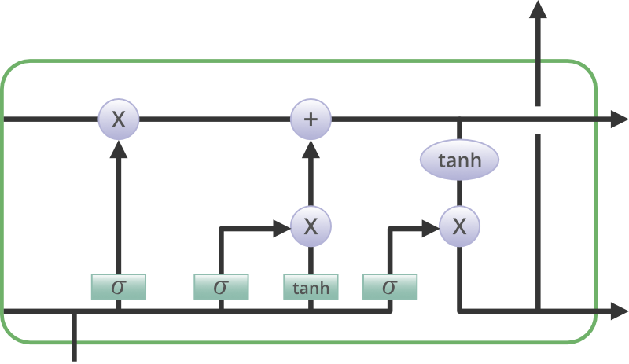

### 3.5 Gated Recurrent Units (GRU) - The Dolphin

* **Characteristics**:
  + Simplified LSTM architecture
  + Efficient memory updates
  + Faster training time
* **Animal Parallel**: Dolphins' streamlined intelligence and quick learning
* **Applications**:
  + Text processing
  + Speech recognition
  + Sentiment analysis
  + Chatbots
* **Strengths: More efficient than LSTM.**
* **Limitations: Less expressive power than LSTM.**

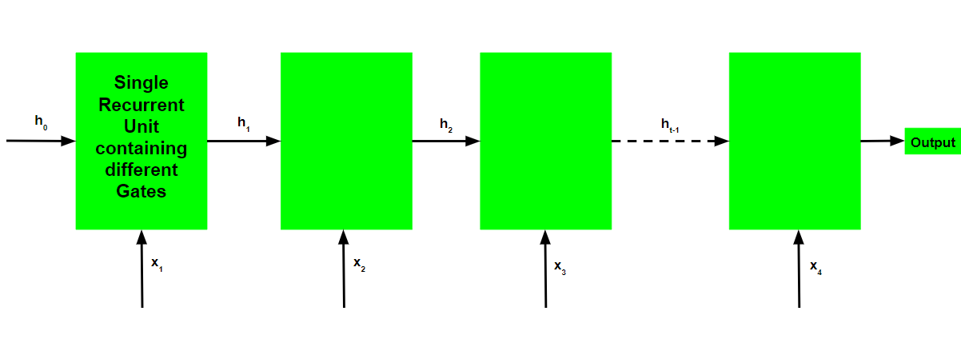

### 3.6 Radial Basis Function Networks (RBFN) - The Jellyfish

* **Characteristics**:
  + Type of feedforward neural network
  + Radial basis functions
  + Distance-based learning
  + Local response patterns
* **Animal Parallel**: Jellyfish's radial structure and local sensing
* **Applications**:
  + Function approximation
  + Pattern recognition
  + System control
* **Strengths: Excellent for nonlinear classification.**
* **Limitations: Sensitive to noisy data.**

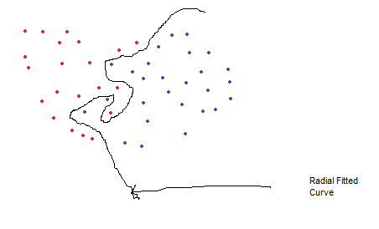

### 3.7 Self-Organizing Maps (SOM) - The Honeybee

* **Characteristics**:
  + Unsupervised learning
  + Topological preservation
  + Dimensional reduction
* **Animal Parallel**: Honeybees' self-organized colony structure
* **Applications**:
  + Data visualization
  + Clustering
  + Feature mapping
  + Anomaly detection
* **Strengths: Preserves topological structure of input data.**
* **Limitations: Lacks direct labeled outputs.**

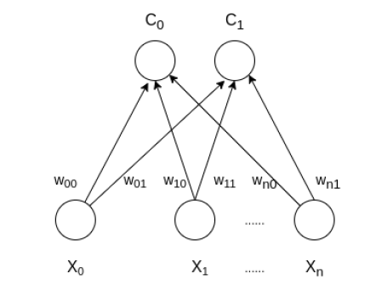

### 3.8 Deep Belief Networks (DBN) - The Owl

* **Characteristics**:
  + Deep architecture
  + Layer-wise pre-training
  + Generative capabilities
* **Animal Parallel**: Owls' deep understanding of their environment
* **Applications**:
  + Feature learning
  + Pattern recognition
  + Data generation
  + Image classification
  + Speech recognition.
* **Strengths: Learns hierarchical representations of data.**
* **Limitations: Computationally demanding.**

### 3.9 Generative Adversarial Networks (GAN) - The Chameleon

* **Characteristics**:
  + Generator-discriminator architecture
  + Competitive learning
  + Creative output generation
  + Create realistic data
* **Animal Parallel**: Chameleons' adaptive nature
* **Applications**:
  + Image generation
  + Style transfer
  + Synthetic data augmentation
  + Deepfake creation,
  + AI-generated art
* **Strengths: Produces highly realistic synthetic content.**
* **Limitations: Training can be unstable.**

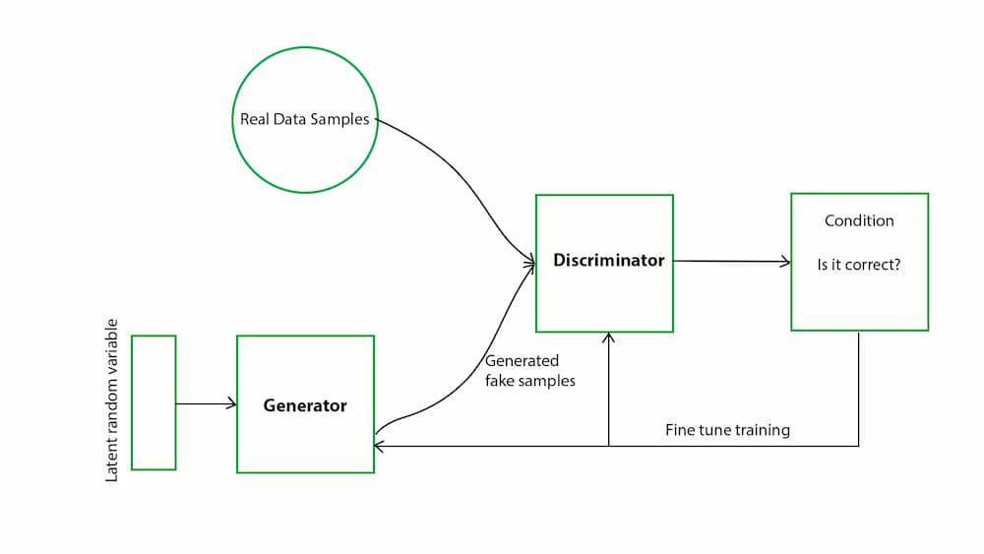

### 3.10 Autoencoders (AE) - The Mirror Bird

* **Characteristics**:
  + Unsupervised neural networks
  + Encoding-decoding architecture
  + Dimensionality reduction
  + Feature learning
* **Animal Parallel**: Mirror birds' ability to reflect and recreate patterns
* **Applications**:
  + Data compression
  + Anomaly detection
  + Feature extraction
  + Noise removal
* **Strengths: Effective at unsupervised learning tasks.**
* **Limitations: Cannot generate labels or classifications.**

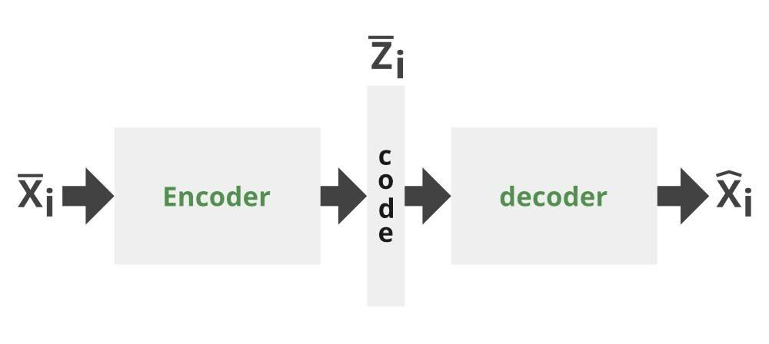

### 3.11 Siamese Neural Network - The Dolphin Pod

### Characteristics:

* + Identical twin networks
  + Similarity comparison
  + Shared weights

### Animal Parallel: Like dolphins recognizing pod members through unique signatures, Siamese networks compare and identify similarities

### Applications:

* + Face recognition
  + Signature verification
  + Image comparison
* **Strengths: Effective in identifying subtle differences.**
* **Limitations: Requires well-structured datasets.**

### 3.12 Capsule Network (CapsNet) - The Octopus's Arms

### Characteristics:

* + Hierarchical structure
  + Part-whole relationships
  + Preserve spatial hierarchies
* **Animal Parallel**: Like an octopus coordinating its arms with spatial awareness, CapsNets understand spatial relationships and object parts
* **Applications**:
  + Image classification
  + Object detection
  + Scene understanding
* **Strengths: Handles hierarchical relationships better than CNNs.**
* **Limitations: Computationally complex.**

### Encoder-Network-Geeksforgeeks

### Decoder-Network-Geeksforgeeks

### 3.13 Transformer Networks - The Octopus

* **Characteristics**:
  + Attention mechanisms
  + Parallel processing
  + Self-attention capabilities
* **Animal Parallel**: Octopuses' distributed intelligence and parallel processing
* **Applications**:
  + Language modeling
  + Machine translation
  + Document summarization
* **Strengths: Scalable and highly effective for NLP.**
* **Limitations: Requires vast amounts of training data.**

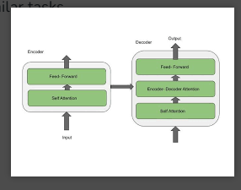

### 3.14 Spiking Neural Network (SNN) - The Firefly's Flash

### Characteristics:

* + Bio-inspired processing
  + Temporal information coding
  + Energy efficiency
  + Mimics the spiking activity of biological neurons

### Animal Parallel: Like fireflies communicating through precise timing of flashes, SNNs process information through timed spikes

### Applications:

* + Neuromorphic computing
  + Cognitive modeling
  + Real-time processing
  + Robotics
  + Sensory processing
* **Strengths: Energy-efficient and well-suited for real-time data.**
* **Limitations: Complex and difficult to train.**

### ****COMPARATIVE PERSPECTIVE****

|  |  |  |  |
| --- | --- | --- | --- |
| Network Type | Strengths | Weaknesses | Best for |
| FNN | Simple & Fast | Cannot process sequential data | Basic classification |
| CNN | Excellent for images | Needs large data | Computer vision |
| RNN | Good for sequences | Vanishing gradient | Time-series, NLP |
| LSTM | Handles long-term dependencies | Computationally expensive | Complex sequences |
| GRU | Efficient and fast | Less expressive than LSTM | Real-time speech processing |
| AE | Compresses data | Cannot classify | Anomaly detection |
| GAN | Creates new data | Difficult to train | Synthetic media |
| Transformer | Best for NLP | Requires high resources | Text generation & NLP |
| RBFN | Good for function approximation | Sensitive to noise | Pattern recognition |
| SOM | Excellent for clustering | No labeled data output | Data visualization |
| DBN | Learns hierarchical representations | Requires large data | Feature extraction |
| CapsNet | Handles spatial hierarchies | Computationally complex | Image recognition |
| SNN | Energy-efficient | Difficult to train | Neuromorphic computing |
| Siamese | Identifies subtle similarities | Needs structured datasets | Face verification |

**THE ZOO CONCEPT**

**To make understanding neural networks engaging, we introduce the "Neural Network Zoo." Here, each type of neural network is represented as an animal that mirrors its learning capabilities. We focus on the Recurrent Neural Network (RNN), represented by a parrot, an intelligent bird known for mimicking sounds and learning sequences over time.**

**Understanding Recurrent Neural Networks through the Lens of a Parrot**

Recurrent Neural Networks (RNNs) are a specialized type of artificial neural network designed for processing sequential data. Unlike traditional feedforward networks, RNNs maintain a memory of previous inputs, enabling them to recognize patterns over time. To illustrate their function, we can compare RNNs to **parrots**, intelligent birds known for their ability to mimic sounds and learn sequences over time. Just as a parrot processes and learns from sequences of sounds over time, Recurrent Neural Networks (RNNs) are designed to handle sequential data by maintaining a form of memory. Like how a parrot can remember and reproduce complex patterns of speech, RNNs excel at processing sequences of information while retaining context from previous inputs.

**Basic Structure and Components**

**RNN Architecture vs. the Parrot's Brain**

RNNs consist of neurons that have recurrent connections, meaning the output of a previous step is fed back into the network as input for the next step. This allows RNNs to maintain a form of short-term memory. RNNs possess a unique architectural feature: loops that allow information to persist, similarly, a parrot's brain that maintains ongoing neural activity to process and remember sequences of sounds. These loops act as the network's memory, similar to how a parrot's brain maintains temporal patterns when learning new vocalizations.

Key components include:

* Input layer: Feeds data into the network, analogous to the parrot's auditory input system (the way it hears and processes speech)
* Hidden Layer with Recurrent Connections: Maintains memory of previous inputs, akin to how a parrot remembers phrases over time (neural pathways in its brain that maintain temporal context)
* Output layer: Produces the final result, much like parrot's vocal production system (repeating learned words in context).

**How RNNs Work**

RNNs process sequential data step by step, with each step influencing future outputs. This makes them well-suited for tasks like speech recognition, time-series forecasting, and natural language processing. An example of this in action is sentiment analysis, where giving it a sentence like “These headphones sound bad”, it can link each word together, updating itself each step to gain the full context, associating the headphones and bad to get a negative sentiment on them. Similarly, a parrot listens to sounds, learns patterns, and repeats them in a structured manner.

**Steps in RNN Processing:**

1. **Receiving Input:** Similar to a parrot hearing a new phrase.
2. **Updating Memory State:** Like a parrot storing the sound in its cognitive system.
3. **Generating Output:** The parrot repeats words in an appropriate context.
4. **Learning over Time:** With training, the parrot refines its responses, just as an RNN improves through backpropagation and gradient descent.

**Memory Mechanism: Short-term and Long-term Memory**

Just as parrots demonstrate both short-term memory for immediate sound reproduction and long-term memory for retained phrases, RNNs employ different memory mechanisms:

* Short-term memory: Handled by the basic RNN structure
* Long-term memory: Managed through advanced architectures like LSTM (Long Short-Term Memory) and GRU (Gated Recurrent Unit)

These mechanisms allow RNNs, like parrots, to maintain context over varying periods.

**Applications: Real-world Usage**

RNNs are widely used in various domains where sequential learning is crucial like speech recognition and translation, prediction tasks such as stock-trends or weather forecasts, and processing text, images, and videos. Their applications in link to our selected animal “Parrot” could be:

* **Speech Recognition:** Much like a parrot mimicking sounds accurately, RNNs process speech patterns and recognize spoken language.
* **Machine Translation:** Just as a parrot learns phrases from multiple languages, RNNs power language translation models.
* **Time-Series Prediction:** RNNs analyze sequential patterns, similar to how parrots associate certain sounds with specific contexts.
* **Chatbots and Text Generation:** Like a parrot responding based on learned phrases, RNNs generate human-like text based on prior data.

**Challenges and Solutions**

Despite their strengths, RNNs face challenges such as the vanishing gradient problem, which affects their ability to learn long-range dependencies. Similarly, parrots may struggle to remember lengthy sentences or complex language structures. Advanced variations like Long Short-Term Memory (LSTM) networks address these issues by improving memory retention.

**Creatives:**

**a) RNN Parrot Anatomy**

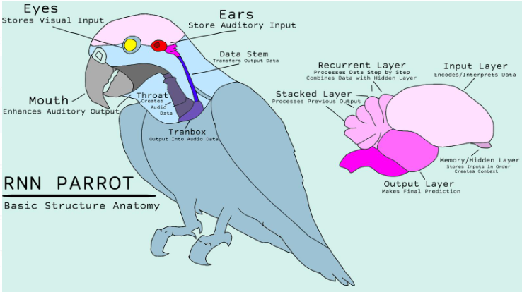

**b) Script:**

If your idea of a zoo is just lions and tigers, you're in for a wild surprise! Meet the Neural Network Zoo! My name is Fiona and I will be your guide for today! Here, we don’t just have animals, we have A.I. animals! I am the RNN Parrot and let me tell you about my relatives. RNN stands for Recurrent Neural Network. Just like a real parrot, RNN can remember things it has heard and can repeat them back. Imagine RNN the Parrot reading you a bedtime story. It remembers the plot, the characters, and even the twists and turns! That’s because RNNs are really good at handling sequences of information. They’re the memory masters of the A.I. world. RNNs are used in things like predicting weather, recognizing speech, and even writing songs! So, think of RNN the Parrot as your super smart, story-telling buddy. Ready to explore more brainy creatures? Stay tuned for our next trip to the Neural Network Zoo! Thank you for watching! We are the Fast Jet Learning Rockets, bringing A.I. to the life.

**CONCLUSION:**

Recurrent Neural Networks (RNNs) are a powerful tool for processing sequential data, much like a parrot that learns and recalls patterns. The parallel between parrots and RNNs extends beyond surface-level similarities. Both systems demonstrate remarkable capabilities in sequence learning, pattern recognition, and temporal processing. Understanding this relationship helps us appreciate the elegant design of RNNs and their continued importance in artificial intelligence applications.

### ****CITATIONS:****

### <https://www.geeksforgeeks.org/types-of-neural-networks/#list-of-types-of-neural-networks>

### <https://www.geeksforgeeks.org/neural-networks-a-beginners-guide/>

### <https://eagleonline.hccs.edu/courses/282423/files/71661048?module_item_id=19318805>

### <https://eagleonline.hccs.edu/courses/282423/files/71912790?module_item_id=19380094>

### [https://aws.amazon.com/what-is/recurrent-neural-network/](https://aws.amazon.com/what-is/recurrent-neural-network/#:~:text=A%20recurrent%20neural%20network%20(RNN,complex%20semantics%20and%20syntax%20rules.)

### https://www.geeksforgeeks.org/introduction-to-recurrent-neural-network/

### ****STATEMENT OF PARTICIPATION:****

### ****Faiza Abdullah:** Worked on complete report compilation and completed the following sections of the report:**

* **Introduction to Neural Networks**

### **Basic structure of Neural Networks**

### **Types of Neural Networks**

### **Comparative perspective**

### **The Zoo concept**

### **Conclusion**

### **Citations**

### **Fine tuning and addition in:**

### **Understanding RNNs through the Lens of a Parrot**

### **RNN Architecture vs. the Parrot's Brain**

### **How RNNs Work**

### **Steps in RNN Processing**

### **Memory Mechanism: Short-term and Long-term Memory**

### **Applications: Real-world Usage**

### **Challenges and Solutions**

**Lyazzat Zilgarina:**

### **Worked on presentation completely.**

### **Developed script of animated video.**

### **Developed animated video.**

**Ryan Yauch:**

### **Preliminary draft on:**

### **RNN and its basic structure**

### **How RNN works**

### **Real-life application**

### **RNN’s connection with Parrot**

### **Citations**

### **RNN Parrot’s Anatomy**

### **Created group logo.**

***Did not participate:***

* Jonah Joseph